### CS-639 Building User Interfaces, Fall 2019, Professor Mutlu

# Assignments — Week 05 | Design | Design Paradigms

In this assignment, you will explore the use of two design paradigms—metaphorical and idiomatic design—in the context of redesigning the UW–Madison course search and enrollment system. Consider any aspect of the system, *e.g.*, search, scheduler, and degree planner, and think about how you would redesign these systems using metaphors and idioms following the instructions provided below. The “aspect” of the system can be the high-level organization of the interface, such as the “master/detail” pattern that the panes of the course search function follow, or a smaller component, such as the “drawer” that shows course sections. As in past assignments, you will create annotated, hand-drawn or digitally created sketches/mock-ups/wireframes supported by design justifications.

### Part 1. **Metaphors**

In this part of the assignment, you will borrow a “brick and mortar” metaphor from the real world that might serve as a good way to organize the functions provided by the system. For example, a [rolodex](https://en.wikipedia.org/wiki/Rolodex) can serve as a good metaphor for large lists, such as the list of courses; [baseball cards](https://en.wikipedia.org/wiki/Baseball_card) might serve as a metaphor for information on each course; and a [weekly planner](https://en.wikipedia.org/wiki/Personal_organizer) can be a good metaphor for the scheduler. Follow the steps below to redesign the system function using metaphorical design:

1. **Identify the system element that you will redesign.** The element can be a major system function, such as the “scheduler,” or a minor component that supports such a function, such as the ability to add courses to a cart.
2. **Search for appropriate real-world metaphors.** Think about situations in the real *physical* world where people perform functions that are similar to what the users do with the function/ component you chose.
3. **Apply metaphor to the design element.** This step would involve creating the appropriate visual and behavioral representations for the metaphor. E.g., if you chose to represent courses as baseball cards that students will collect, what should appear on the cards, and how should students collect them? Remember to consider and define both the **appearance** and **behavior** of your metaphorical redesign.

Provide an annotated mock-up/sketch of your redesign below. Your mock-up/sketch can be in any level of fidelity, e.g., a hand-drawn conceptual design sketch or a wireframe created in Adobe XD—whichever you prefer. Take photos of hand-drawn designs and screenshots of digitally created ones. Your annotations should highlight the different components of the metaphor, including its appearance and behavior. In a brief paragraph, justify your choice of the metaphor and describe how the metaphor supports the user’s task in using the system element you chose to redesign.

Browsing products on Amazon, going to the full store directory is just a bunch of links.

<annotated-mock-up/sketch>

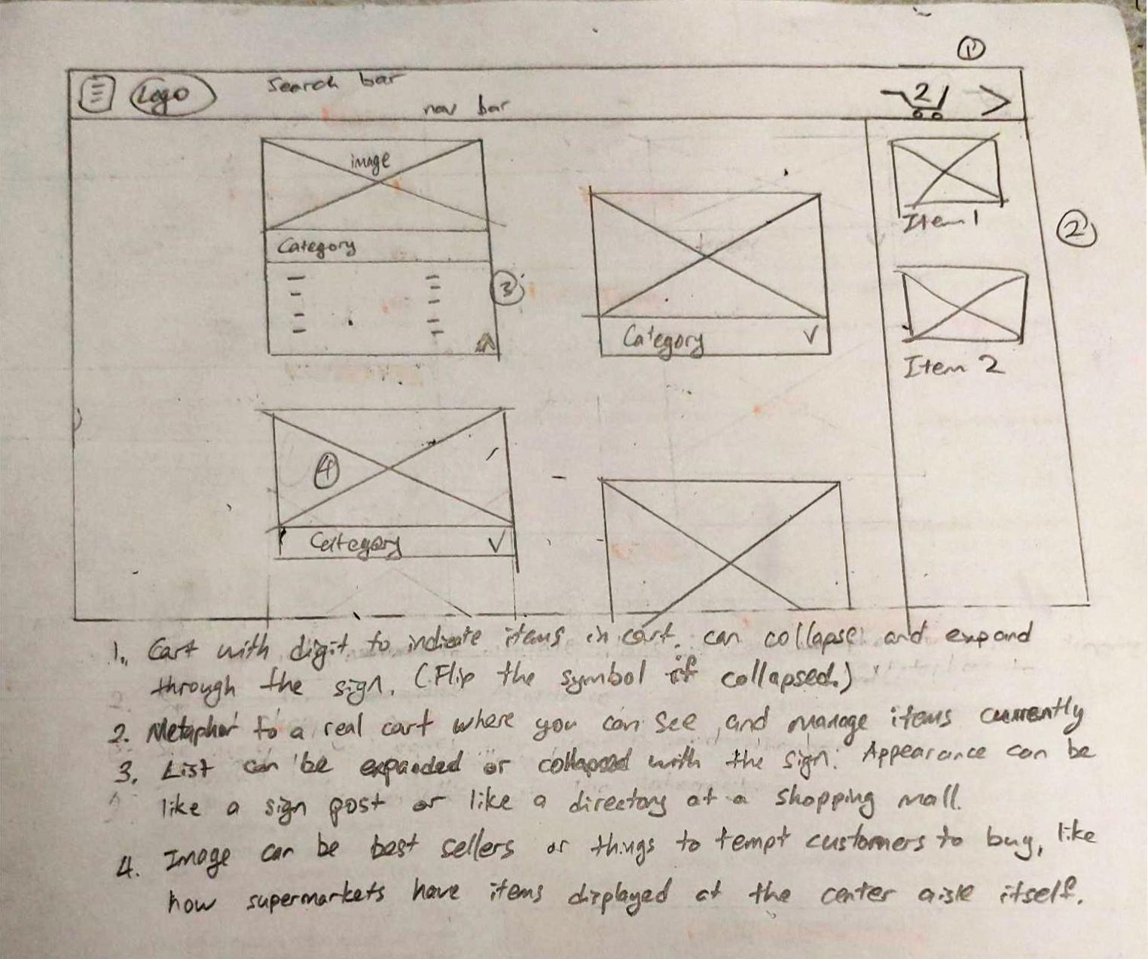

<design-justification>

The metaphor I was aiming was how there are signs at the top of the aisle, say at a supermarket. The page is like the main aisle where you can see all the sign at a glance, then walk closer to see details or look down the aisle for more things. And since the list is a manageable size of 2 at a time (like how aisle signs only have left and/or right), we can sort the items just like how supermarkets employ psychology. Essentially, exciting and colorful in front, necessity middle, impulse buying at the end. Users wouldn’t have to learn how to navigate the website since its similar to real life markets.

### Part 2. **Idioms**

In this part of the assignment, you will practice idiomatic design by redesigning either the same system element you focused on in Part 1 or a different system element. Remember that idioms are highly expressive, dedicated interaction capabilities that users might learn. To practice idiomatic design in this part of the assignment, follow the steps below:

1. **Study the element.** Inspect the element to analyze how it is visually represented and how it behaves, *i.e.*, characterize the current idiom. What is the essential function of the element? For example, if there is a “drawer” that comes out to show more information on a course selection, how does that work, and what are the visual elements that make it up?
2. **Devise an alternative structure.** Now that you understand the essential functionality of the element, can you think of alternative—and potentially more effective—idioms to support its functioning? In the example above, what might be a novel way to present the necessary information?
3. **Define the idiom.** Remember the three levels of the idiom from Cooper et al., *idioms*, *compounds,* and *primitives*. Describe how your idiom will work at each level. What visual elements will cue users into using them, and how will your new design behave?

To describe your idiomatic design, provide an annotated mock-up/sketch below in the same fashion as you did in Part 1. Support your sketch/mock-up with a brief paragraph that justifies your design choices and describes the elements of the idiom.

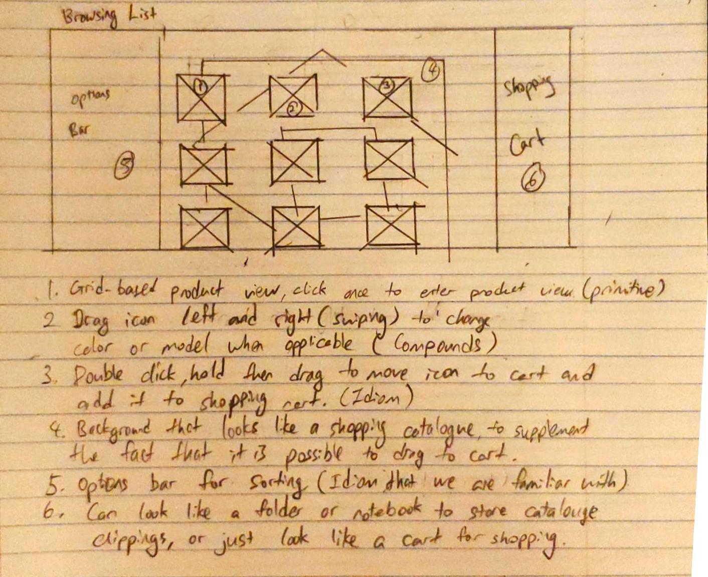<annotated-mock-up/sketch>

<design-justification>

The page I was looking at is the amazon browsing page, when you browse products by categories. The primitive element of the page is simply clicking the icons, which will bring you to the product page. My new design would be to add a compound function into the static images, where users will be able to slide the product image to see other models, and colors. How the users can be cued to learn the function is to set the image to change automatically after a set period of time. Next, there will also be a function to simply drag and drop into cart. This, however, will be a hidden affordance. There can simply be a tutorial to teach the users about the function when they first visit the site or is an unregistered user.